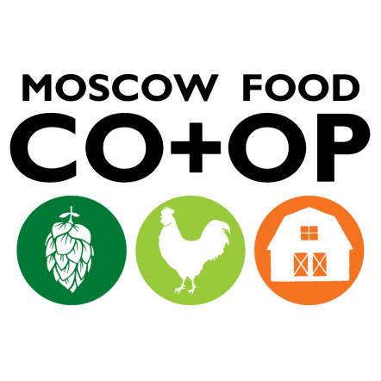
General Manager FYI
October 30, 2023
No action needed

OPERATIONS UPDATES
SALES: Department sales recap. The difference reported is between the current year and the prior year.

September | 2021 | 2022 | 2023 | Difference
Total Sales | $867,551.86 | $959,935.32 | $1,020,901.29 | 6.8%
Grocery | $406,756.73 | $434,281.00 | $442,435.21 | 1.9%
Wellness | $117,381.79 | $104,696.11 | $118,414.39 | 13.1%
Prepared Foods | $126,260.95 | $169,138.54 | $185,222.01 | 9.5%
Bakery | $45,295.44 | $50,924.49 | $65,372.54 | 27.4%
Meat | $71,348.73 | $75,771.19 | $77,390.20 | 2.1%
Produce | $90,941.10 | $109,499.24 | $123,746.92 | 13.0%
Campus | $10,731.58 | $15,624.75 | $14,835.99 | -5.1%
Customer Count | 29950 | 33707 | 34519 | 2.4%
Basket Size | $28.03 | $27.38 | $28.58 | 4.4%

New Ownerships:

CUSTOMER SERVICE – following the Fall NCG Meeting and based on the information presented, we’re tracking different metrics. Here’s the summary (for all NCG Co-ops):

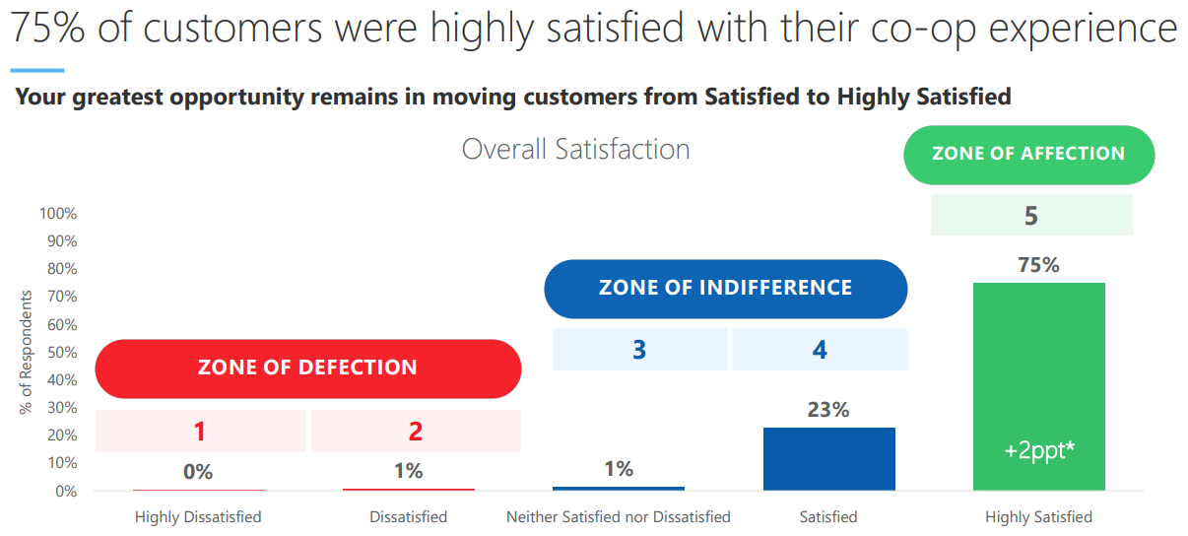
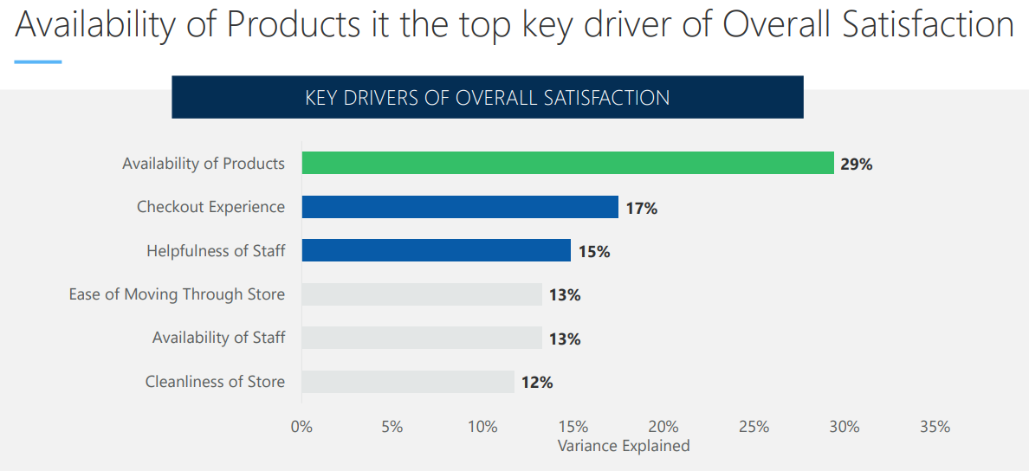

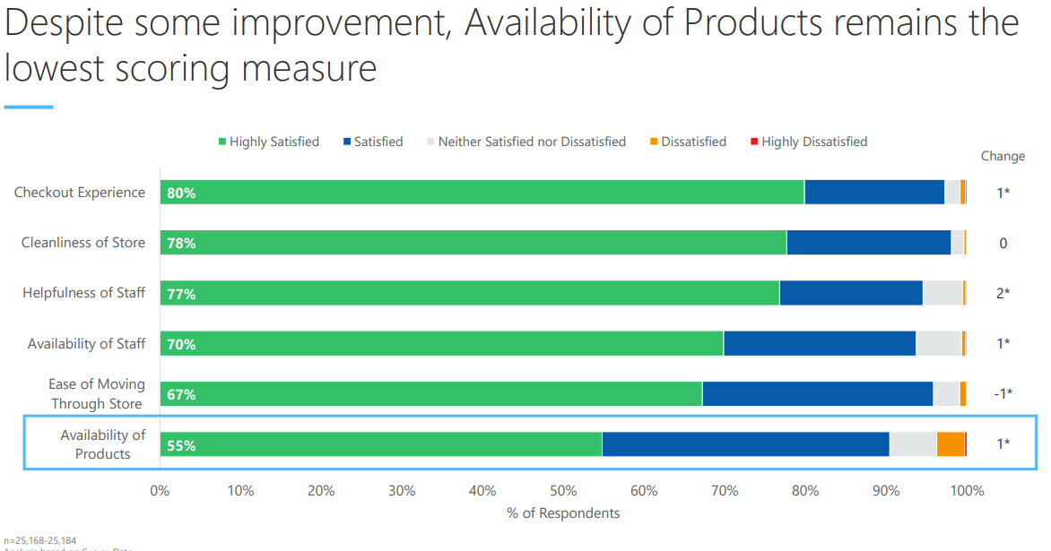
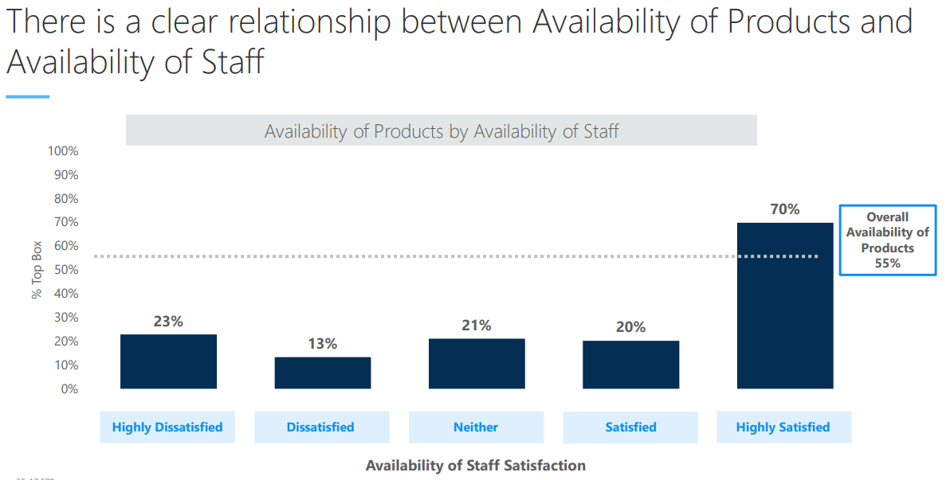

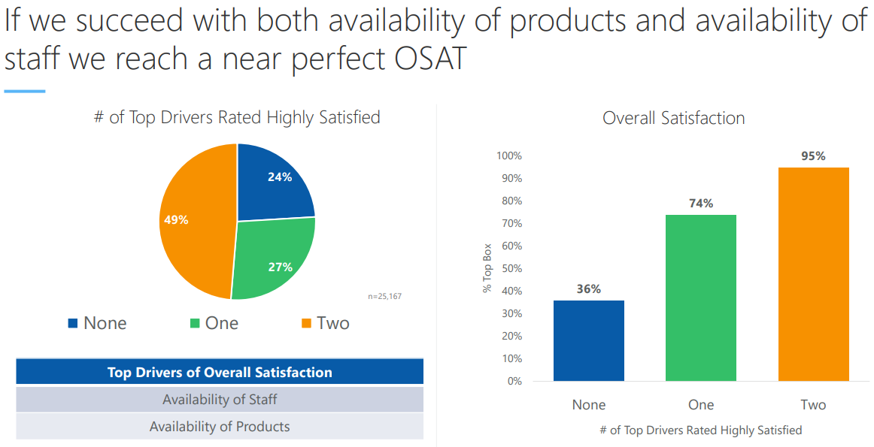
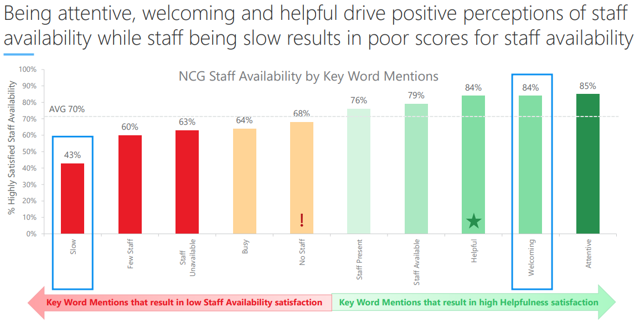

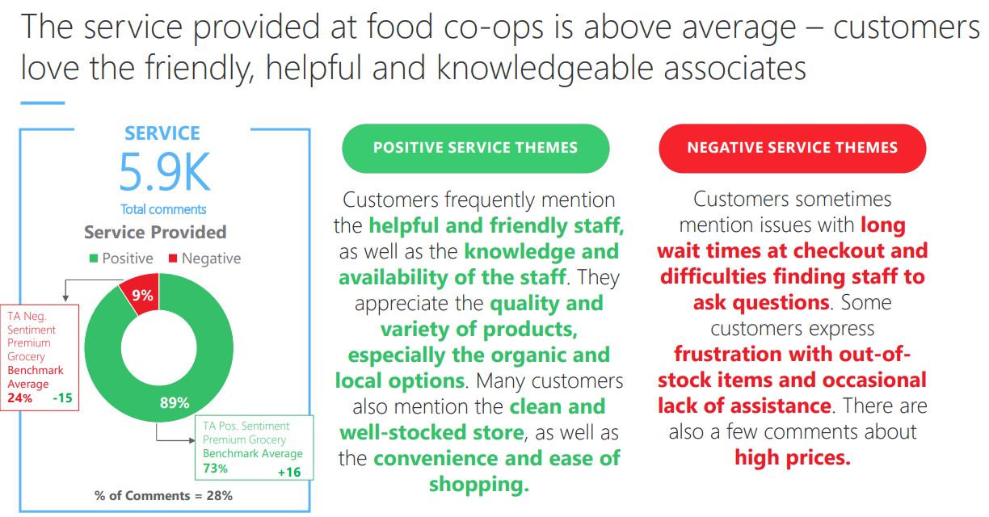

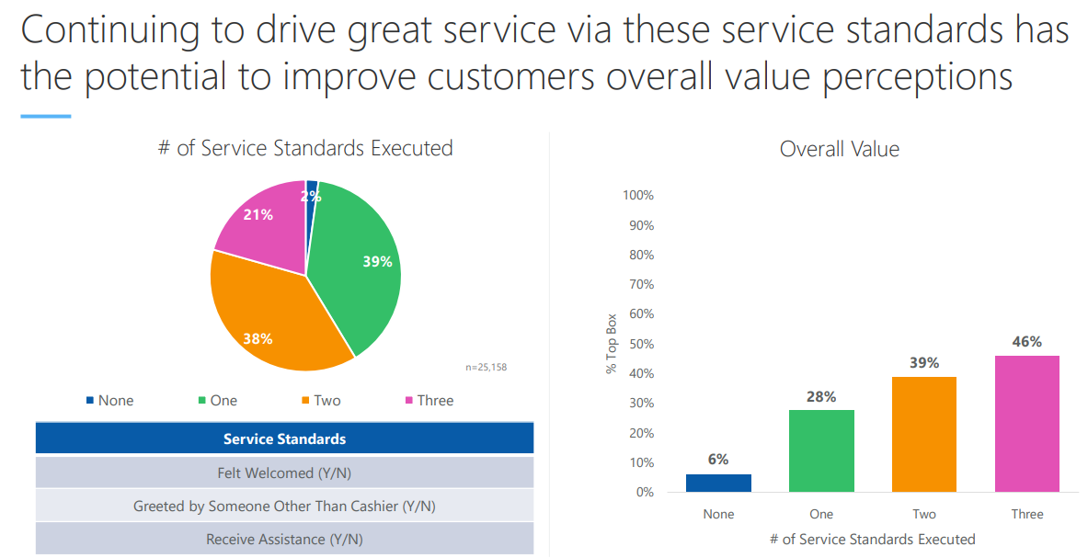

Key Drivers of Overall Satisfaction (OSAT): availability of products, helpfulness of staff. And checkout experience

Customer Experience Survey Comments
- Comments are attached in an excel spreadsheet

Store Operations Updates

General
- The 2023 Employee Opinion Survey is complete. The Management Team is zooming with our consultant on November 8th to review the results.
- Market Study Update
  - Our study is complete and I’ve received the report.
- NCG offered a webinar in their DEI series titled “Visual Diversity” which I was able to participate in. We learned about “quick wins” versus making lasting change, which is a slow process. We also learned about some of the ways businesses falsely advertise the diversity of their staff (something we should never do) and how to prioritize inclusion and equity, rather than diversity, because they improve retention.
- New Hire orientation is making a comeback. Prior to COVID, we had half-day in-person orientation for all new employees. We’re looking forward to rekindling this onboarding experience starting in November.
- We had a visit from NCG’s Prepared Foods Specialist, Ken Wallace, earlier this month. He was impressed with our PF department recovery (he said things are looking fantastic) and organized a call for our team of buyers with our KeHE team. (KeHE is a distributor similar to UNFI)
- We are replacing our espresso machines both downtown and on campus.
UNFI
- I’ve attached five documents from UNFI for reference that provide context about our business supply chain issues- these are only included in case you’re interested in more information:
  - October Service Level Update
  - October Category Insights – Natural
  - October Category Insights – Conventional
  - 2 Weekly Service Level Updates, Conventional and Natural

Marketing Updates
- Moscowberfest was on 10/7 in the entertainment district. We sold brats, pretzels and a housemade beer cheese sauce. We sold out of everything about 30 minutes before the event was over. We’re calling that a huge success!
- Mark your calendars for Tasteful Thursdays in November and December and for our Wine, Cheese, and Chocolates tasting event on November 30th.
- Marketing is collaborating with dynamic and creative students majoring in marketing communications at Washington State University (Crimson Creative) to help elevate our social media presence. With a shared objective of enhancing our brand visibility and engagement, this partnership will create fresh ideas and innovative strategies for our marketing efforts. Drawing from their academic knowledge and youthful perspective, these students can bring a new energy and help to connect with millennial and gen Z in meaningful ways.
  - The students first started out by conducting a media audit (looking at our Facebook and Instagram accounts). Based on their feedback, they recommended starting by creating store tour videos, ranging from 15 seconds to 90 seconds. By providing a visual journey through our store, potential customers can get a firsthand look that Moscow Food Co-op is not just a store but a hub for community, sustainability, and delicious food. The student should have the video ready November 6th.

